COSC 4377 – Networking - Kevin B Long



Homework #5
Due 11:59pm, Sunday, 31 March 2019
Some problems due later, see below
Multiple submissions accepted.

Name: James Richardson Peoplesoft ID: 1555520
- (10 pts) Complete the 7th Wireshark lab on TCP

- (8 pts)

An app originally had 12KB to send. Both send and receive TCP buffer sizes are 2KB. At the moment, there remains only 2KB in the app’s buffer to be handed down to TCP. Also, the sender has just put the contents of his buffer onto the network headed towards the receiver. Answer the following questions:

- What is the sequence number be found in the TCP Header?
  - We have sent a total of 10KB, the sequence number denotes the start byte of the next piece we are sending which in this case would be 10240.

- What will the length of the payload be?
  - The payload has the same length as the buffer size. So 2KB or 2048 bytes.

- What size of receiver buffer will the receiver advertise back in his acknowledgment?
  - The rwnd bit will be set to 0 in the acklowledgement by the reciever, this tells the sender to not send any more packets. The reciever is telling the sender that its buffer is filled, so it is advertising that it has a buffer size of 0.

- What will the sender need to transmit after this packet before continuing with the last 2K?
  - The sender will continually probe the receiver with a one byte payload. This payload has actual data from the sender’s window. When the receiver sends an ack back, this message will contain the window size of the receiver, which should hopefully be 2048.

- (4x4=16 pts) Recursive/Iterative DNS Queries

- Which scenario type always results in the greatest number of DNS queries, regardless of the server settings?

Root name server has intermediate name server cached. Basically the root knows the guy who knows the guy who knows where the thing is. Gotta ask a lot of people to figure out where the thing is.

- Which has the shortest?

Local name server has the destination ip cached. The first person we ask knows where the thing is.

- If you wish to minimize the number of queries handled by the root server across all caching scenarios, what settings do you need?
Have Local name server be iterative! If the local name server is set to be recursive, it will try to offload a lot of the work to the next guy (the root name server). We just need to ask root for what we need and then go there.

- If you wish to hide as much of the identity of your DNS infrastructure from the local name servers as possible, which query method should you choose? Iterative or Recursive?

Recursive is more privacy-centric if you want to hide from the local dns server. With recursive we will go find out the information with our own systems rather than telling someone where it is.

- (4x4=16 pts) TCP Congestion Control

Consider the following graph:
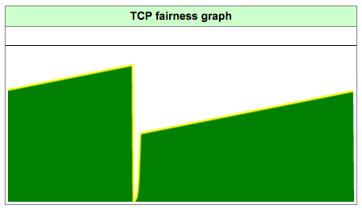
- There are 3 situations in the animation that can cause this dip in the bandwidth being used by a single workstation. What are they?

- A timeout with reno or tahoe recovery.

ii. Reaching the bandwidth limit (and dropping a packet?) with tahoe recovery.

iii. A triple ack with a tahoe recovery

- Add a second workstation and let the simulation run for a few moments, and then experiment introducing errors. When will the bandwidth consumption be at its lowest?

If both workstations have timeouts at the same time it will be the lowest. Otherwise with no errors the bandwidth is the least after a few cycles of reaching the network bandwidth and the workstations are synced up and drop to half bandwidth at the same time.

- (26 pts) TCP Retransmissions
Consider the figure below in which a TCP sender and receiver communicate over a connection in which the sender-to-receiver segments may be lost.
- The TCP sender has window size of 5 segments. The diagram shows when they are transmitted. Let’s also number the segments starting with 1.
- The initial sender-to-receiver sequence number is 100
- All sender-to-receiver segments each contain 100 bytes.
- The delay between the sender and the receiver is 7 time units (the numbers are correct even though it looks like 8 comes before 5 – just ignore that) So for example, the first segment arrives at the receiver at t=8, and a receiver-to-sender ACK for this segment arrives at the TCP sender at t=15.
- There is no processing delay in the receiving host, so it acknowledges every packet as soon as it arrives.

As shown in the figure, one of the five segments in the initial round is lost between the sender and the receiver, but none of the ACKs are lost. Answer the following questions:

TCP Congestion Control 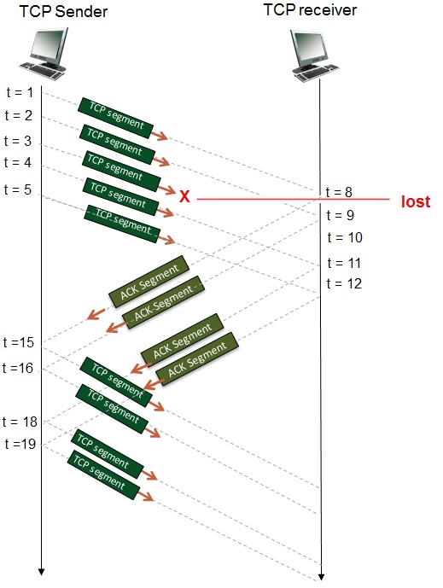

- (1 pts) Will we receive any duplicate ACKs? If so, how many and with what sequence number(s)?

Two duplicate acks for sequence number 300.

- (1 pts) In the beginning, the window starts with what sequence number? This is the value of cwnd.

The window size is 500, we can see this because there are 5 outstanding packets of 100 bytes each.
The window starts at sequence number 100.

- (2 pts) In the beginning, what is the highest sequence number inside the window? Remember, the window begins at cwnd and continues for the number of segments in the window multiplied by the size of each segment.

If by in the beginning you mean before the acks, it would be seq=500.
After we get back the acks it would be 700 (because two valid acks make it back).

- (5 pts) What is the sequence number for each of the first five packets sent?
Time | Seq #
Time 1 | 100
Time 2 | 200
Time 3 | 300
Time 4 | 400
Time 5 | 500

- (5 pts) What is the acknowledgment number sent for each of the first 5 segments (packets)?
Segment | Seq #
1 | 200
2 | 300
3 | XXX
4 | 300
5 | 300
- (2 pts) After the first ACK from this round is received back at the sender, what will the value of cwnd be? Assume the window size remains fixed.

600. I’m not sure what you mean by the window size can’t increase? Cwnd will increase without bound unless we hit a loss event. SO I assume we just won’t send out any more packets.

- (2 pts) After all the ACKs from this round that will be received are received, what will the value of cwnd be, and the last byte number in the window? Assume the window size remains fixed.

Cwnd: 900 last byte: 700

- (2 pts) What must happen in order for transmissions to continue? Select all that apply.

☐ Packet 3 must be retransmitted due to a triple-duplicate ACK
x Packet 3 must be retransmitted due to a timeout (timer expiration)
☐ All packets in the window must be resent, segment #1-5
☐ All packets in the window must be resent, segment #3
☐ All packets in the window must be resent, segment #3-7
☐ All packets in the window must be resent, segment #3-9
☐ All packets in the window must be resent, segment #5-9
Additionally if we consider farther in the future, those additional four packets that were sent out will all receive an ack of seq # 300 back. If we consider this, then #300 will be retransmitted because of the duplicate acks from those packets.

- (2 pts) What will happen when the missing packet 3 is finally received? Select the best one from each group.
x The receiver will acknowledge with byte #300
☐ The receiver will acknowledge with byte #500
☐ The receiver will acknowledge with byte #700
☐ The receiver will acknowledge with byte #900
☐ Other. The receiver will acknowledge with byte #___________

☐The receiver will deliver packet 3 to the application
x The receiver will deliver packets 3-5 to the application
☐ The receiver will deliver packets 3-7 to the application
☐ The receiver will deliver packets 3-9 to the application
☐ Other. The receiver will deliver to the application packets __________

In the book it says that it is optional for implementations of TCP to store sequence numbers that arrive out of order. If this is an implementation that stores them, then the retriever will ack byte #500 and deliver packets 3-5. Otherwise it will ack back with #300 and only hand packet 3 up to the next layer (because it would have thrown away 4 and 5).

- (2 pts) If you change the missing packet to be packet 2, will your answer for part h change? Explain.

It will cause a triple duplicate ack and then packet number 2 will be resent.

- (2 pts) Did you spot any serious problems with the diagram (and the simulator)?

Yes, the weird timing mix up that you mentioned. Also there is still 5 time slices on the right even though one of them was lost.

- (24 pts) Consider figure following diagram.

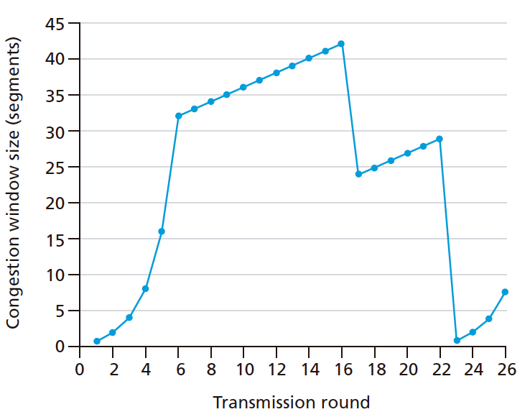
We are running TCP Reno.
- (2 pts) In what mode is our sender at transmission round 1?
x Slow Start ☐ Congestion Avoidance

- (2 pts) What is the initial value of ssthresh? 32 or 33

- (2 pts) What’s the significance of this value? In other words, what changes as we cross that threshold?

Up to that point we double the number of outgoing packets. After the number of outgoing packets passes that threshold the number of outgoing packets increases by 1 after all of the packets have been acked.

- (2 pts) What kind of loss is depicted first, and during which transmission round is it detected?

x Triple-Duplicate ACK ☐ Timeout Round? 15

- (2 pts) What is the value of ssthresh after that loss?

Half of what it was at the point when the loss occurred. So 21

- (2 pts) What mode are we in after the first loss?
☐ Slow Start x Congestion Avoidance

- (2 pts) What kind of loss is depicted last, and during which transmission round is it detected?
☐ Triple-Duplicate ACK x Timeout Round? 23

- (2 pts) How many packets are transmitted in the first 10 rounds?

1 + 2 + 4 + 8 + 16 + 32 + 33 + 34 + 35 + 36 = 201

If your MSS was set to 100 bytes, in what round on this graph would we have finished sending 21,000 bytes’ worth of segments?

Round 21160. With no loss events, cwnd would be 242.

- (8 pts) Finally, use what you’ve learned to label the graph showing where the various points at which ssthresh changes. Include round 1 so you can label the initial value. Each time you change ssthresh, also list the value of cwnd. You can list it in tabular format instead of you like. Not all rows may be used.

Round | ssthresh | cwnd
1 | 33 | 1
16 | 21 | 24
23 | 15 | 1

